**Practical File of**

**Informatics Practices (065)**

Class –XII

AISSCE-2017-18



Guided By: Developed By:

Mr. A.K. Pandey Sai Ashish

(HOD Computer) Roll no: ________

L.B.S. School R.K. Puram

|  |  |  |
| --- | --- | --- |
| S.no | Practical Name | Page no. |
| 1 | ABC Consultancy |  |
| 2 | Wage Calculator |  |
| 3 | Theatre Booking System |  |
| 4 | e-Learning Point |  |
| 5 | Happy Shopping |  |
| 6 | ABC Insurance Company |  |
| 7 | Ice-Cream Parlour |  |
| 8 | Teach Well Public School |  |
| 9 | ABC School |  |
| 10 | Incentive Calculator |  |
| 11 | Dynamic List Demo |  |
| 12 | Fashion Gallery |  |
| 13 | Super Store Bill |  |
| 14 | Avon Tools |  |
| 15 | Country-Capital Test |  |
| 16 | Arithmetic Calculator |  |
| 17 | Even or Odd |  |
| 18 | Largest of three numbers |  |
| 19 | Second largest of three numbers |  |
| 20 | Cross tables of n1 to n2 |  |
| 21 | Factorial from 1 to n |  |
| 22 | Binary to decimal conversion |  |
| 23 | Sum and product of multi-digit number |  |
| 24 | Sum of series 1/1!-2/2!+..upto n. |  |
| 25 | Prime number |  |
| 26 | Armstrong number |  |
| 27 | LCM of two numbers |  |
| 28 | HCF of two numbers |  |
| 29 | Palindrome number |  |
| 30 | Prime numbers from 2 to n. |  |
| 31 | Class Rectangle |  |
| 32 | Class Telcall |  |
| 33 | Class Function Overloading |  |
| 34 | Employee Details |  |
| 35 | Customised Data Entry |  |
| 36 | Record Navigation |  |
| 37 | Search, Delete And Update |  |
| 38 | Master-Detail Form |  |
| 39 | Global Warming |  |
| 40 | Admission Enquiry Form |  |
| 41 | Use of DML commands |  |
| 42 | MYSQL Functions |  |

Question1-

Objective :

Understanding the use of various controls in real life application.

Task-

ABC Consultancy is a placement organisation, assists job seekers .The Entry form has to be designed to facilitate following features:

1. When Submit button is pressed ,the following things should happen.

(a)If post Graduate is checked, the 10+2 and Graduate checkboxes should also get selected automatically.

(b) If Graduate is checked , the 10+2 checkbox should also get selected automatically.

(c)A Message box with “Hello, Mr. / Mrs. You are registered” should get displayed.

|  |  |
| --- | --- |
| Control Name | Description. |
| * nameTF | Used to input name |
| * maleRB,femaleRB | Used to identify gender of user. |
| * tenCB,GraduateCB   postCB | Used to identify qualification of user |
| * scienceRB,artsRB,   commerceRB | Used to identify stream of user |
| * submitBTN | Used to receive input. |
| * clearBTN | Used to clear all controls |

Run Time Screen Shot:

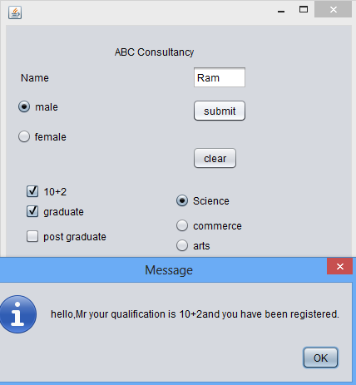

Source view:

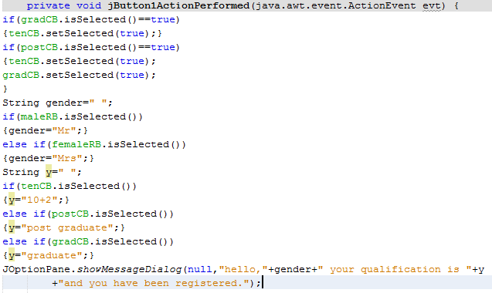

Question2-

**Objective**: Understanding the need of Real life applications.

Task:

The Milton Casting Company has developed an application to calculate the wage of its workers.

|  |  |
| --- | --- |
| Control Name   * nameTF * maleRB,femaleRB * skilledCB * daysTF,wageTF | Description.  Used to input name  Used to identify gender of user.  Used to check whether worker is skilled or not.  Used to input and output days worked  and wage respectively. |

Run Time Screen Shot.

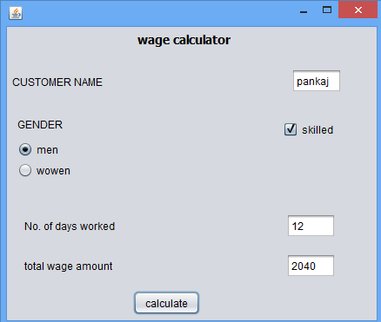

Source view:

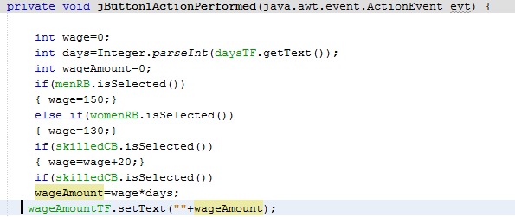

Question3-

**Objective-**Understanding and using the radio button in Real-life applications to determine

selection of choices and performing calculations accordingly.

Task-

To develop a computerised Booking System for Entertainment paradise

Run Time Screen Shot: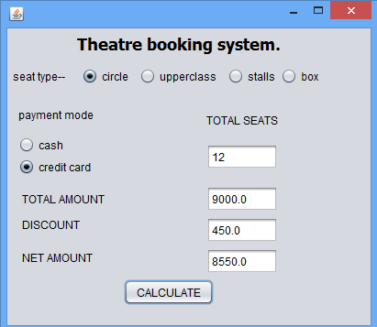

Source view:

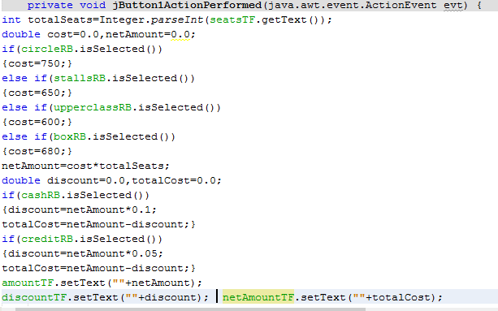

Question No.4:

Objective: Displaying images on a label and Text Area control.

**Task-**

To develop an e-learning application.

Run Time Screen Shot-

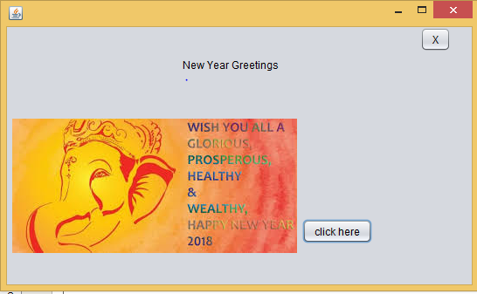

Source view:



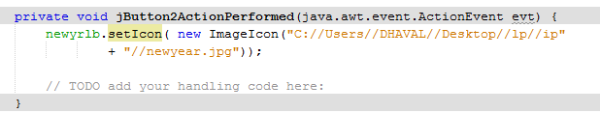



Q5:

Objective: Understanding and using the Radio Buttons in Real-life application to determine

the selection of choice and calculations accordingly.

Run Time Screen Shot:

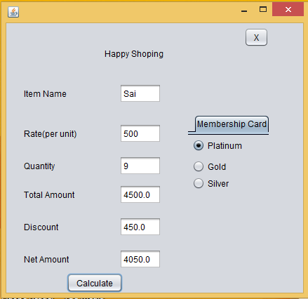

Source view:

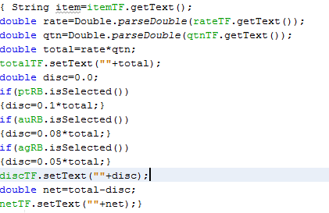

Q6.

Objective: Understanding and using the Radio Buttons in Real-life application to determine

the selection of choice and displaying a message

accordingly

Run Time Screen Shot:

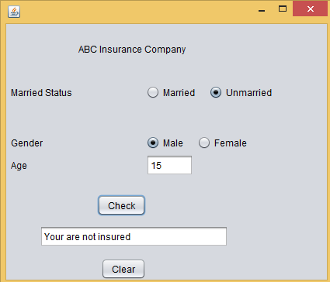

Source view:

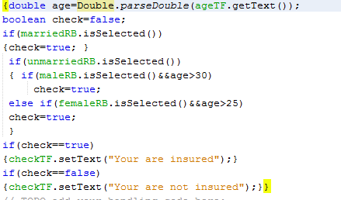

Q7.

Objective: Understanding and using the Check Boxes in Real-life application to determine the selection of choice and performing calculations accordingly.

Run Time Screen Shot:

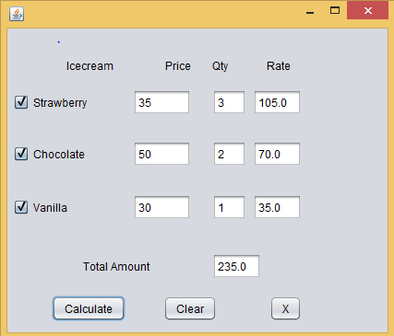

Source view:

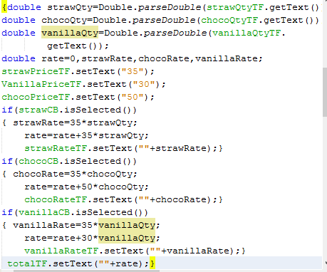

Q8.

Objective: Understanding and using the Radio Buttons and Check Boxes in Real-life application to determine the selection of choice and calculations accordingly.

Run Time Screen Shot:

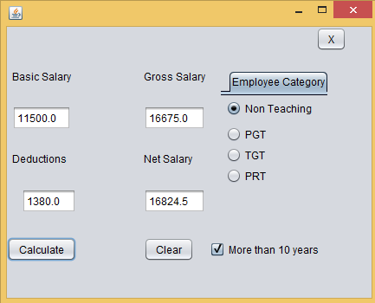

Source view:

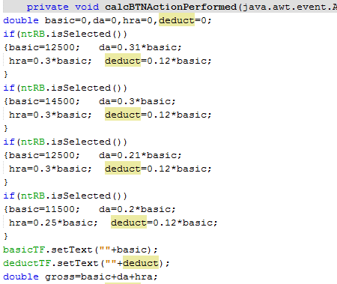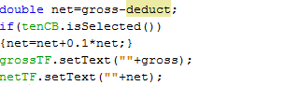

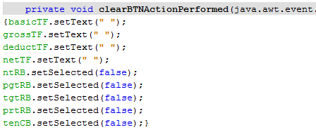

Q9.

Objective: Understanding and using the Radio Buttons in Real-life application to determine

the selection of choice and calculations accordingly.

Run Time Screen Shot:

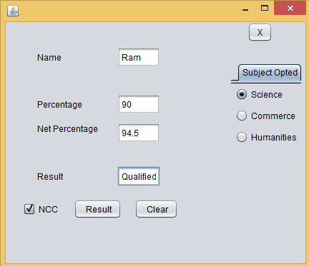

Source view:

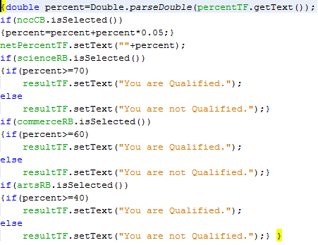

Q10.

Objective: Understanding and using the Radio Buttons in Real-life application to determine

the selection of choice and performing calculations accordingly.

Run Time Screen Shot:

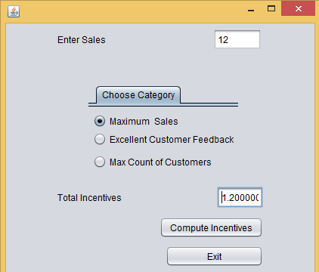

Source view:

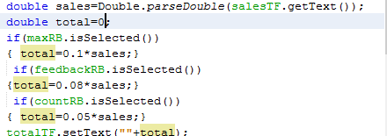

Q11.

Objective: Demonstration of use of List Dynamically through code.

Run Time Screen Shot

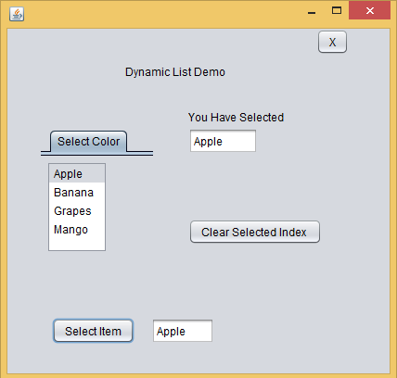

Source view:



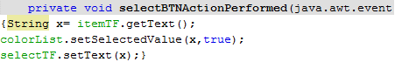

Q12.

Objective: Understanding the need of Real-life applications.

Run Time Screen Shot:

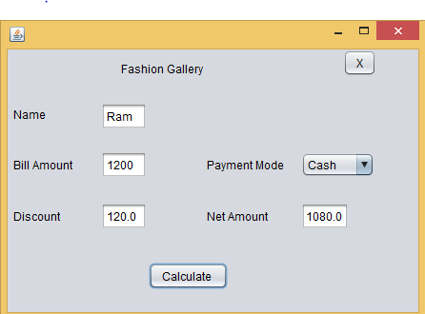

Source view:

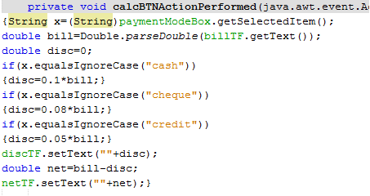

Q13.

Objective: Understanding and using the Radio Buttons in Real-life application to determine

the selection of choice and calculations accordingly.

Run Time Screen Shot:

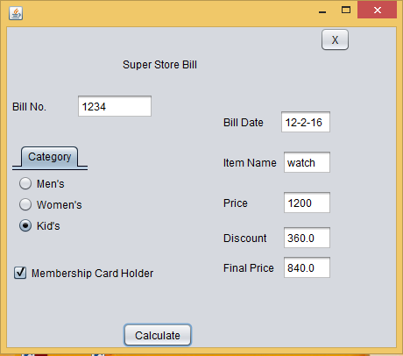

Source view:

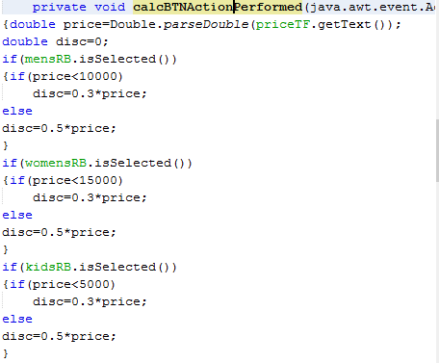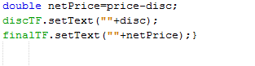

Q14.

Objective: Understanding and using the Radio Buttons in Real-life application to determine

the selection of choice and calculations accordingly.

Run Time Screen Shot:

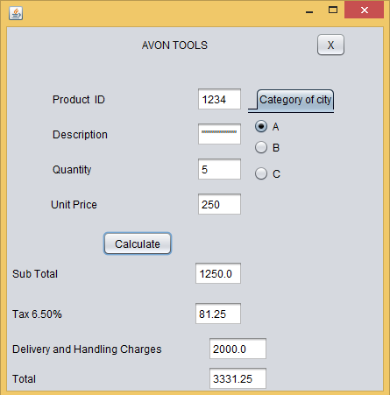

Source view:

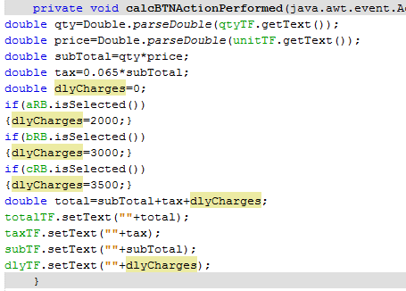

Q15.

Objective: Understanding and using the Radio Buttons in Real-life application to determine

the selection of choice and calculations accordingly.

Run Time Screen Shot:

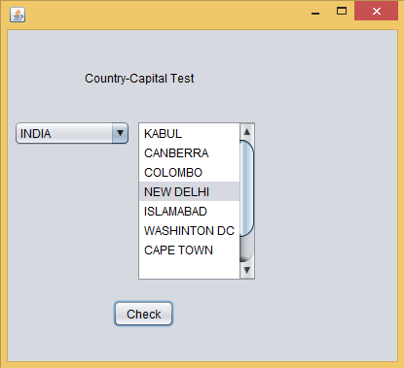

Source view:

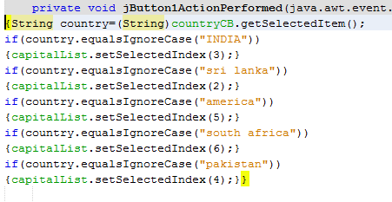

Q16.

Objective: Using switch case write a program to enter two numbers and an arithmetic operator

And make a 5-function calculator i.e.+,*,-,/,%.

Run Time Screen Shot:

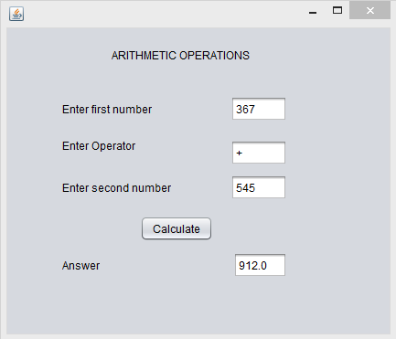

Source view:

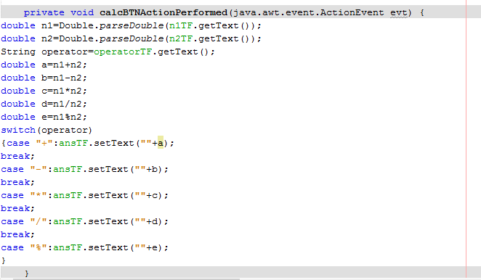

Q17.

Objective: To design a GUI application and to find out whether a given number is odd or even

Run Time Screen Shot:

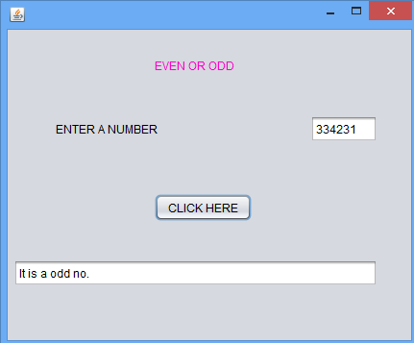

Source view:

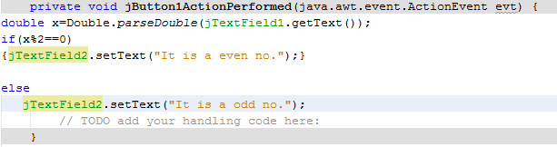

Q18.

Objective: To design a GUI application and to find out largest of three numbers.

Run Time Screen Shot:

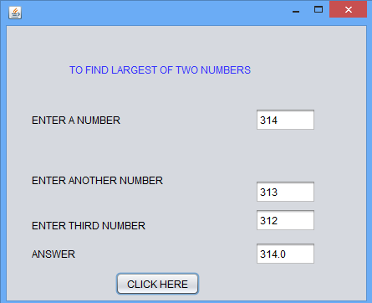

Source view:

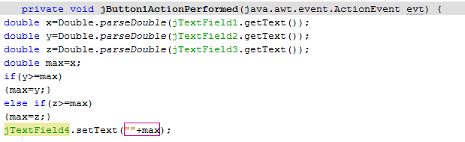

Q19

Objective: Write a program to find second largest of three numbers.

Run Time Screen Shot:

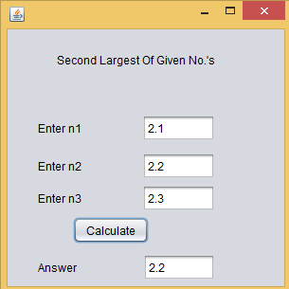

Source view:

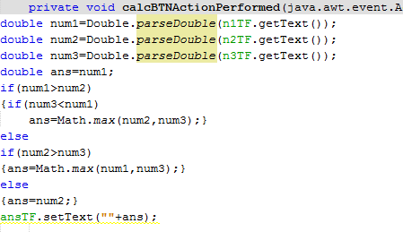

Q20

Objective: Write a program to print cross tables of n1 to n2 in a text area . Input n1 and n2.

Run Time Screen Shot: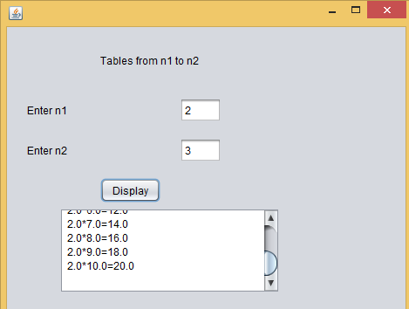

Source view:

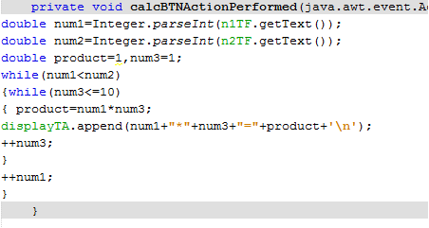

Q21

Objective: Write a program to find factorial of each number from 1 to n.

Run Time Screen Shot:

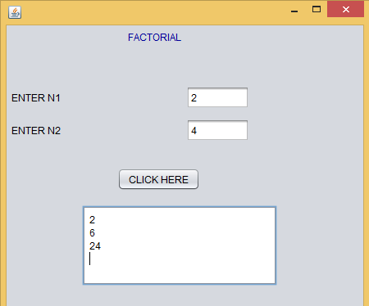

Source view:

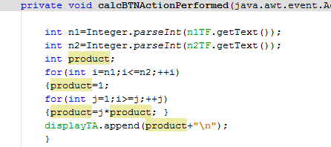

Q22.

Objective: To design a GUI application and to input a binary number and find out equivalent decimal.

Run Time Screen Shot:

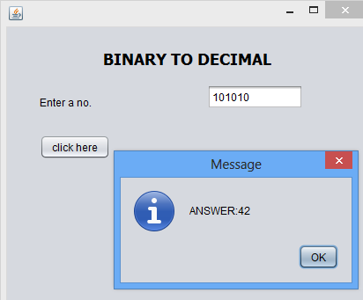

Source view:

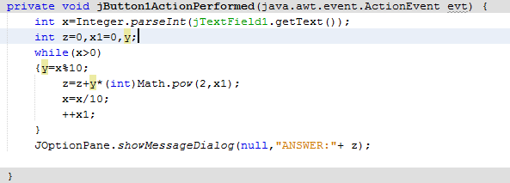

Q23

Objective: Write a program to find sum and product of digits.

Run Time Screen Shot:

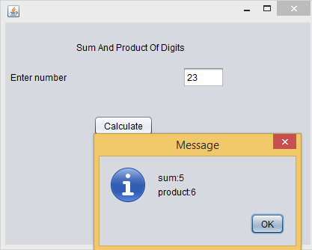

Source view:



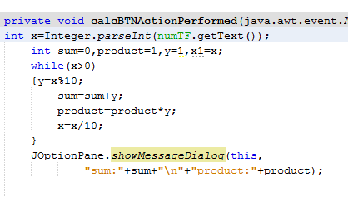

Q24

Objective: Write a program to sum of series: 1/1!-2/2!+3/3!-4/4! ……. upto n terms. Input n.

Run Time Screen Shot:

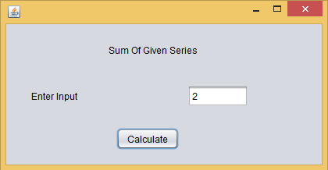

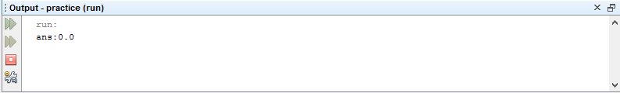

Source view:

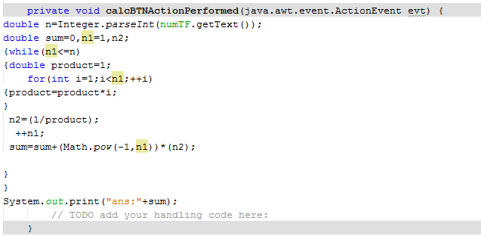

Q25.

Objective: To design a GUI application and to find out whether a given number is prime or not.

Run Time Screen Shot:

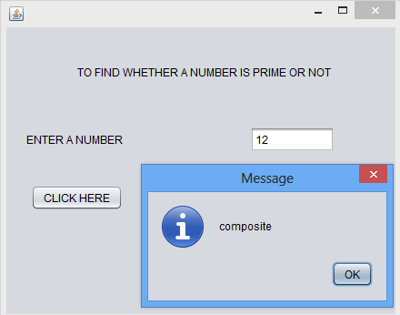

Source view:

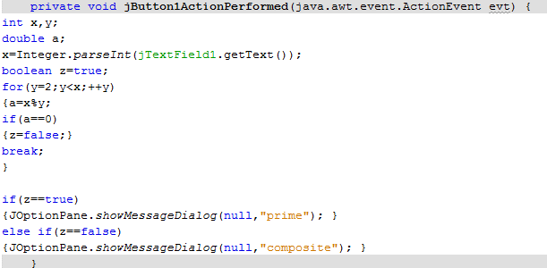

Q26.

Objective: Write a program to test whether a given no. is Armstrong or not.

Run Time Screen Shot:

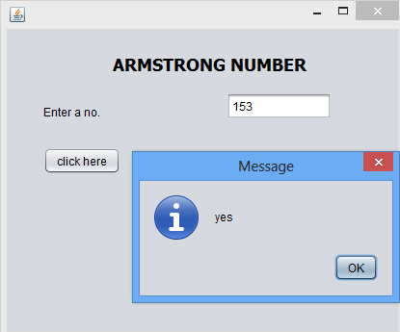

Source view:

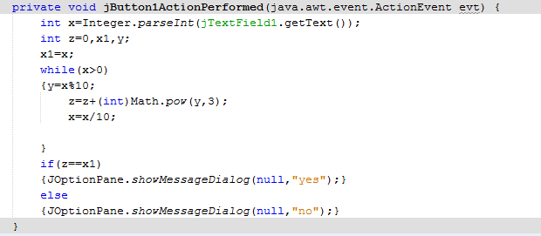

Q27:

Objective: Write a program to find lcm of two given numbers.

Run Time Screen Shot:

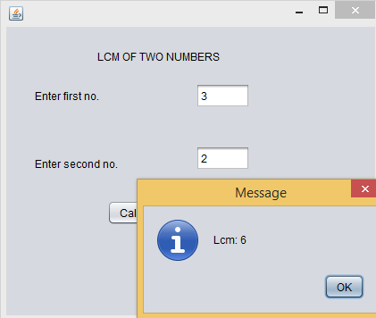

Source view:

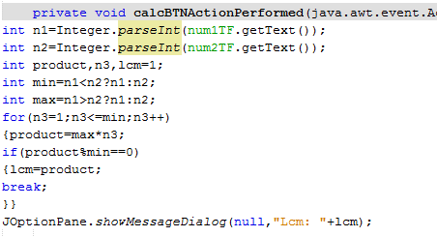

Q28:

Objective: Write a program to find hcf of two given numbers.

Run Time Screen Shot:

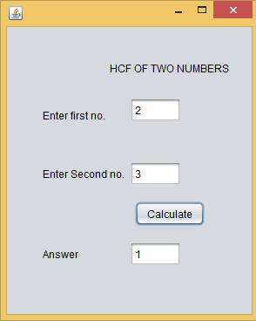

Source view:

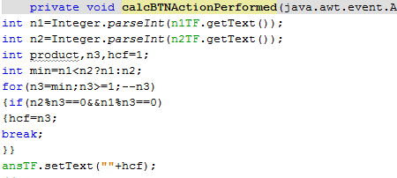

Q29:

Objective: To design a GUI application and to find out whether a number is palindrome number or not.

Run Time Screen Shot:

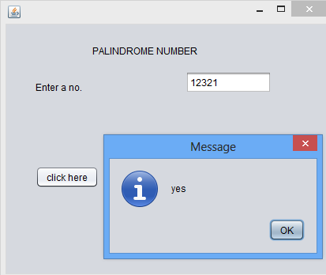

Source view:

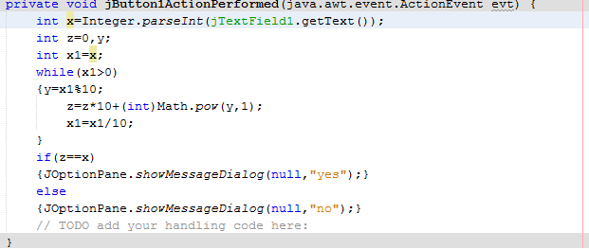

Q30:

Objective: Write a program to display all prime numbers from 2 to n.

Run Time Screen Shot:

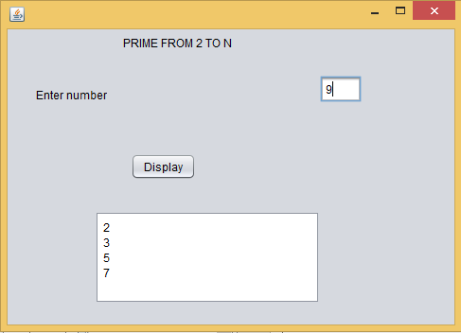

Source view:

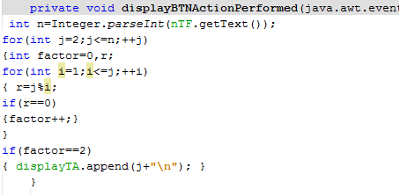

**Problems on Classes**

Q31:

Objective 31: Write a Class Rectangle to calculate

area , perimeter & diagonal.

Source view:

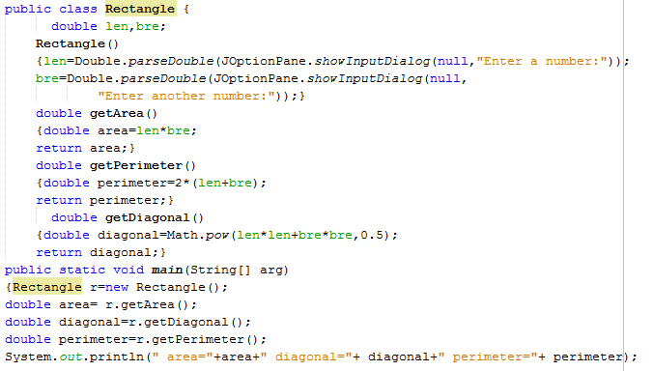

Run-Time ScreenShot

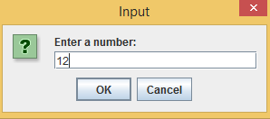

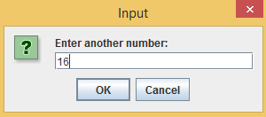

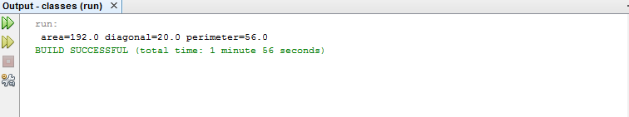

Q32:

Objective : A class **Telcall** calculates the monthly phone bill of a customer.

create an object of type Telcall and display phone bill.

Source view:

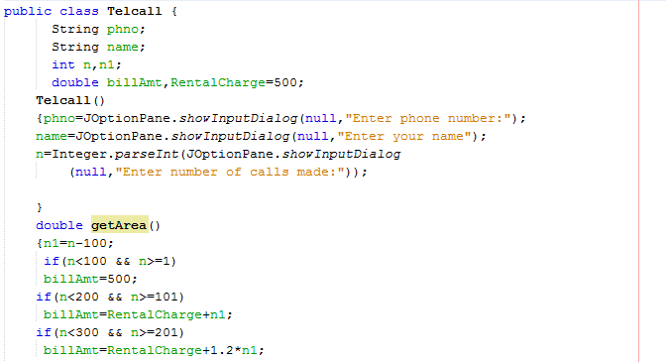

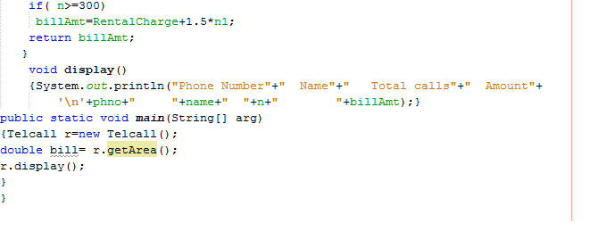

Run-Time ScreenShot:

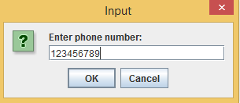

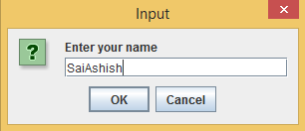

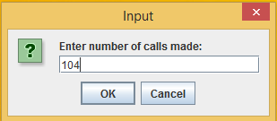

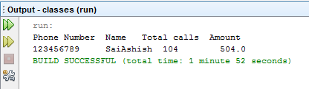

Q33:

Objective : Implementing Function Overloading through methods and showing polymorphism.

Source view:

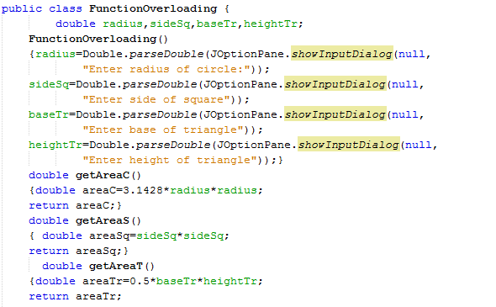

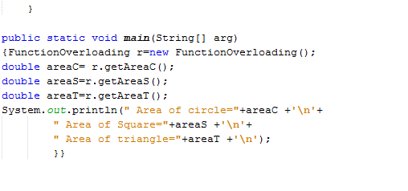

Run-Time ScreenShot:

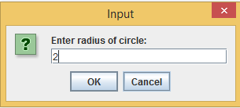

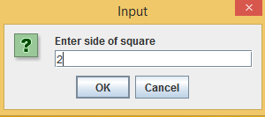

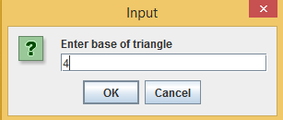

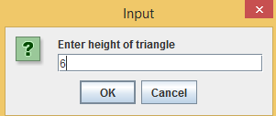

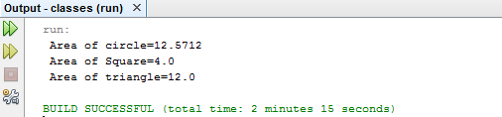

CONNECTIVITY PROBLEMS

Q34.

Objective : Understanding the Database Handling in Java application.

Run Time Screen Shot:

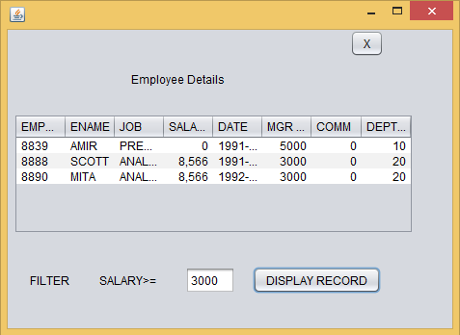

Source view:

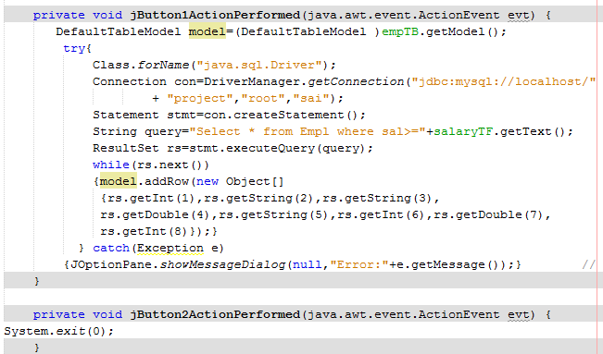

Q35:

Objective : Understanding the Database Handling in Java application.

Run Time Screen Shot:

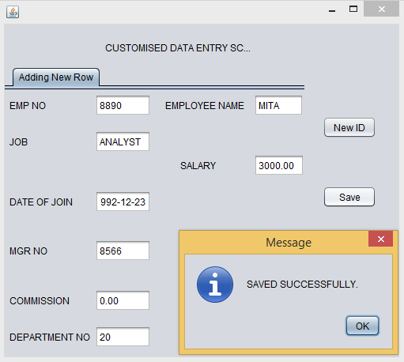

Source view:



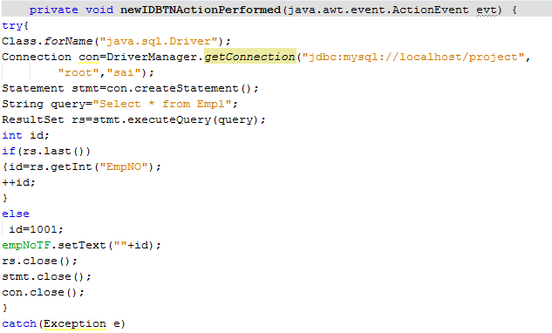

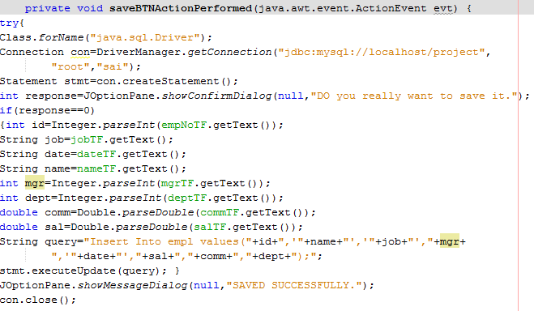

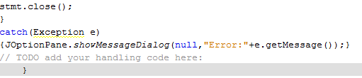

Q36:

Objective : Understanding the Database Handling in Java application.

Run Time Screen Shot:

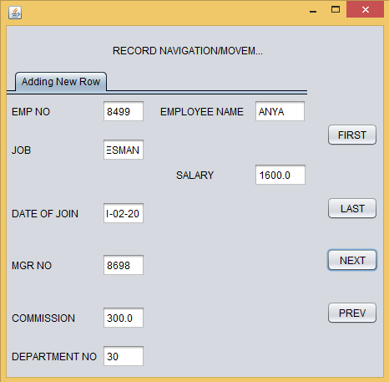

Source view:



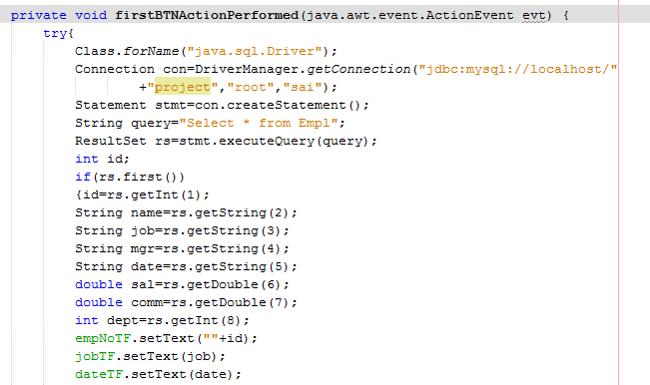

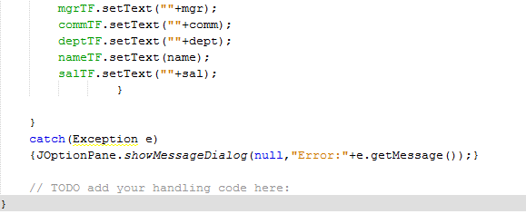

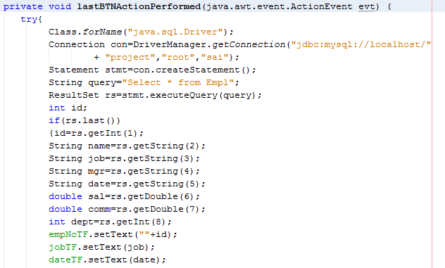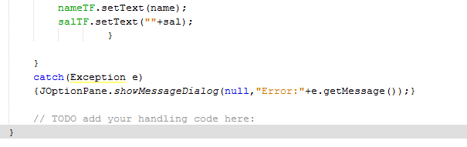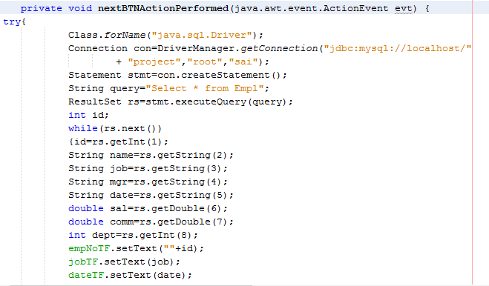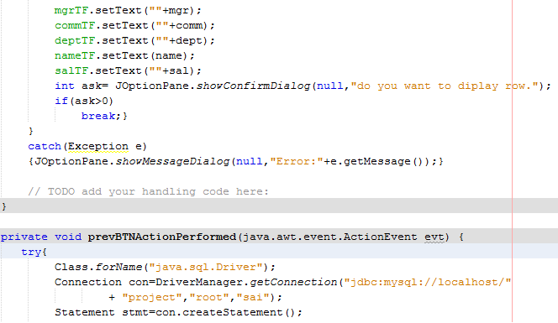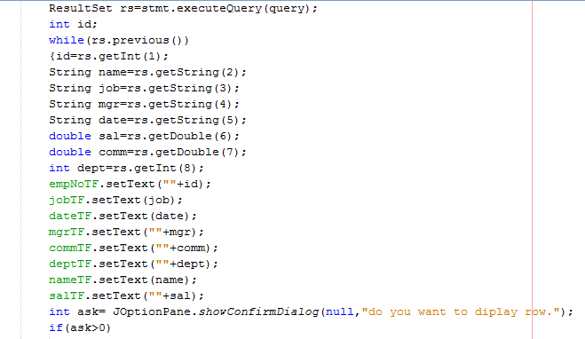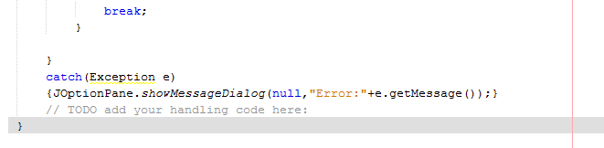

Q37.

Objective : Understanding the Database Handling in Java application.

Run Time Screen Shot:

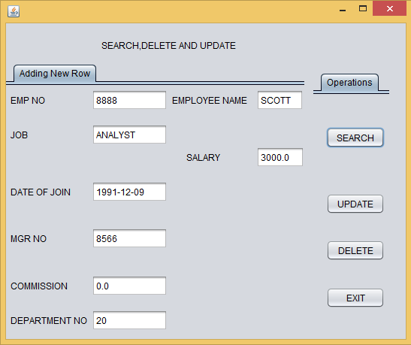

Source view:

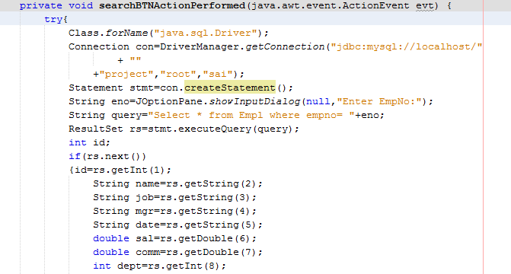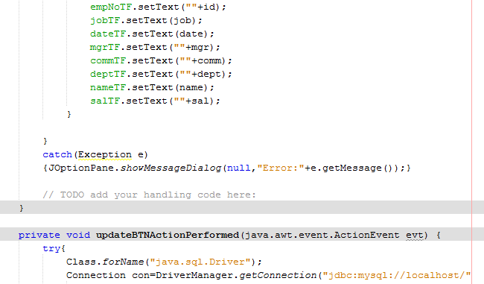

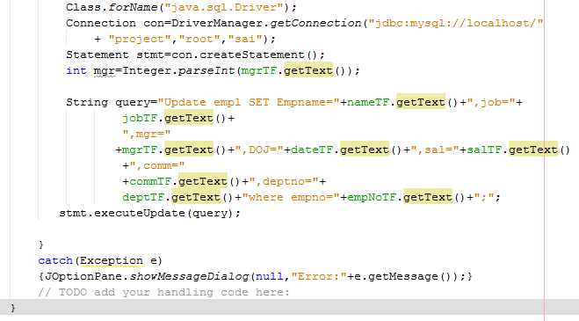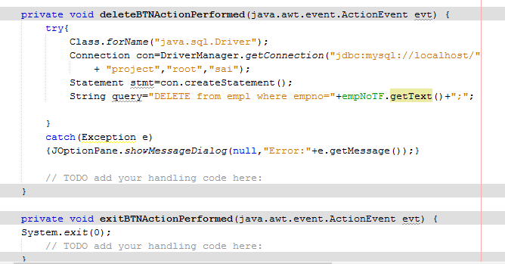Q38:

Objective : Understanding the Database Handling in Java application.

Run Time Screen Shot:

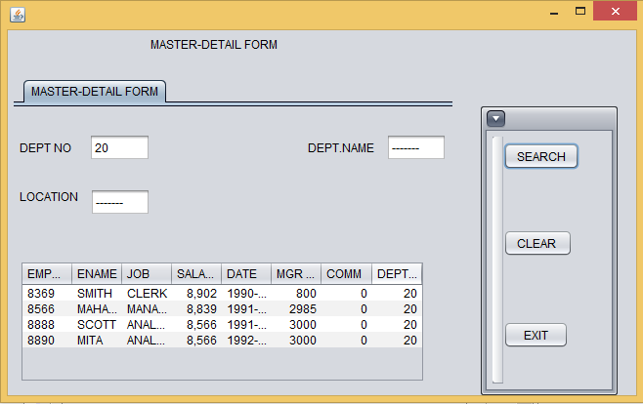

Source view:



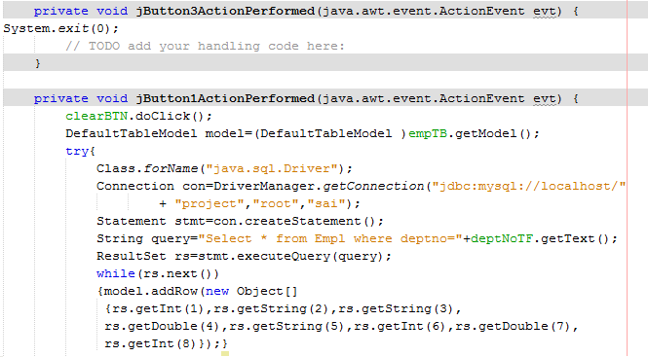

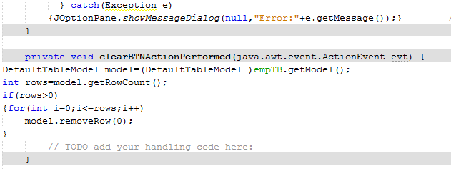

MYSQL PROBLEMS:

Q 41.

**OBJECTIVE:**Understanding the use of DML commands at MYSQL platform.

41.1

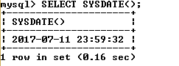

41.2

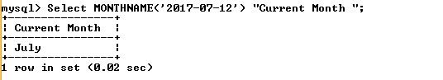

41.3

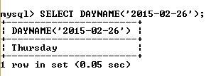

41.4

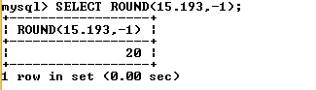

41.5

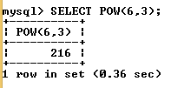

41.6

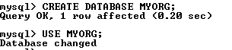

41.7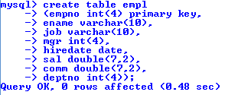

41.8



41.9

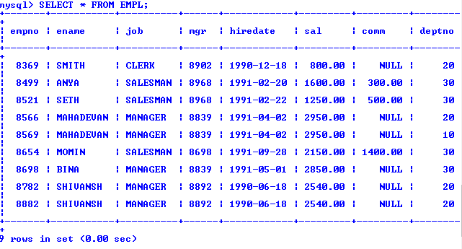

41.10

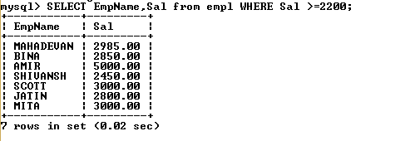

41.11

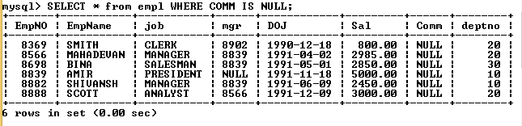

41.12

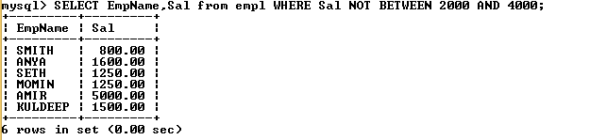

41.13



41.14

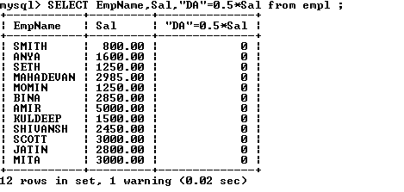

41.15

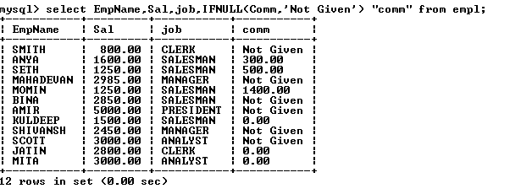

41.16

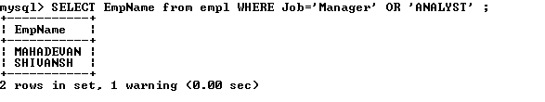

41.17

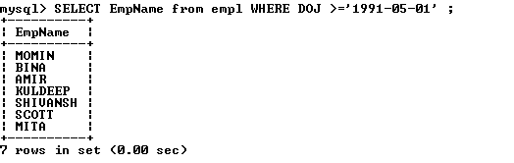

41.18

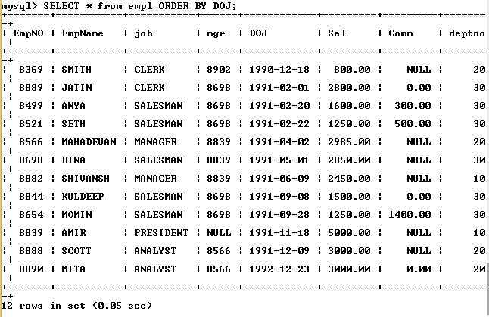

41.19

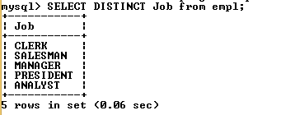

Q42:

**OBJECTIVE:** Understanding the use of DML commands at MYSQL functions.

42.1

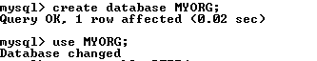

42.2

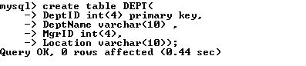

42.3

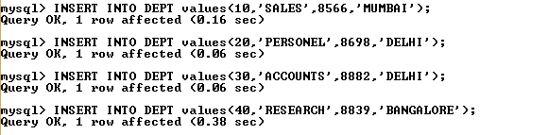

42.4



42.5



42.6

Q43.

**OBJECTIVE:** Understanding the use of DML commands at MYSQL platform.

43.1

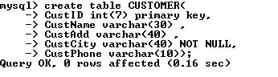

43.2

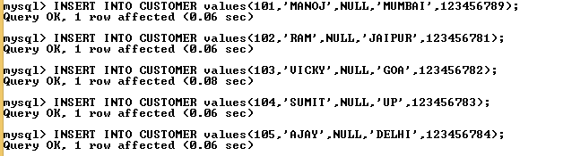

43.3

43.4



43.5

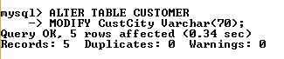

43.6



 Source view:

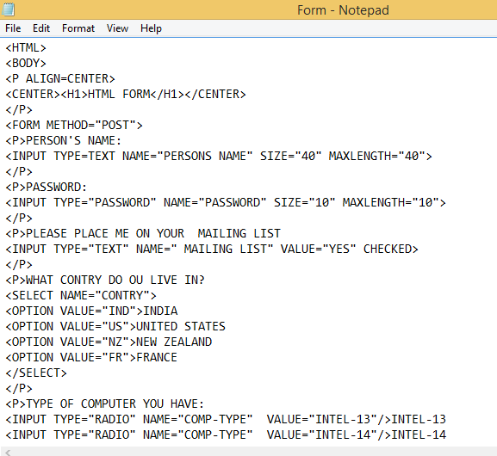

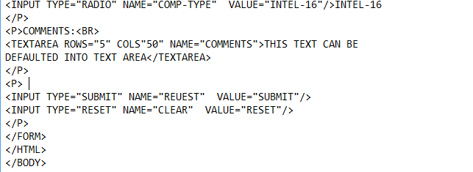

HTML PROBLEMS:

QUESTION 39:

OBJECTIVE:Understanding the Web page and use of different tags and attributes

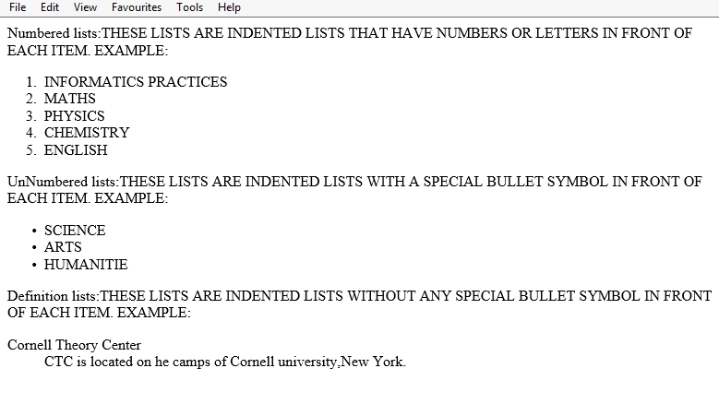

Source view:

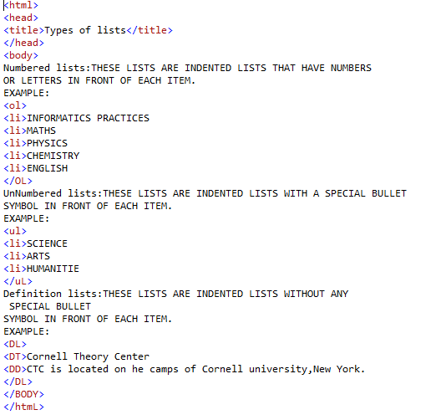

Question No.4:

Objective: Displaying images on a label and Text Area control.

**Task-**

To develop an e-learning application.

Run Time Screen Shot-



Source view:







QUESTION 41:

OBJECTIVE:Understanding the xml structure and use of different components to design an interactive form.

Source view:

|  |  |
| --- | --- |
| <?xml version="1.0"?>  <?xml-stylesheet type="text/css" href="xmlpartsstyle.css"?>  <PARTS>  <TITLE>Computer Parts</TITLE>  <PART>  <ITEM>Motherboard</ITEM>  <MANUFACTURER>ASUS</MANUFACTURER>  <MODEL>P3B-F</MODEL>  <COST> 123.00</COST>  </PART>  <PART>  <ITEM>Video Card</ITEM>  <MANUFACTURER>ATI</MANUFACTURER>  <MODEL>All-in-Wonder Pro</MODEL>  <COST> 160.00</COST>  </PART>  <PART>  <ITEM>Sound Card</ITEM>  <MANUFACTURER>Creative Labs</MANUFACTURER>  <MODEL>Sound Blaster Live</MODEL>  <COST> 80.00</COST>  </PART>  <PART>  <ITEMᡋ inch Monitor</ITEM>  <MANUFACTURER>LG Electronics</MANUFACTURER>  <MODEL> 995E</MODEL>  <COST> 290.00</COST>  </PART>  </PARTS> |  |
|  |  |

**The Style File**

PARTS

{ display: block }

TITLE

{ display: block;

font-family: arial;

color: #008000;

font-weight: 600;

font-size: 22;

margin-top: 12pt;

text-align: center }

PART

{ display: block }

ITEM

{ display: block;

font-family: arial;

color: #000080;

font-weight: 400;

margin-left: 15pt;

margin-top: 12pt;

font-size: 18 }

MANUFACTURER

{ display: block;

font-family: arial;

color: #600060;

font-weight: 400;

margin-left: 45pt;

margin-top: 5pt;

font-size: 18 }

MODEL

{ display: block;

font-family: arial;

color: #006000;

font-weight: 400;

margin-left: 45pt;

margin-top: 5pt;

font-size: 18 }

COST

{ display: block;

font-family: arial;

color: #800000;

font-weight: 400;

margin-left: 45pt;

margin-top: 5pt;

font-size: 18 }

Run Time Screen Shot-

